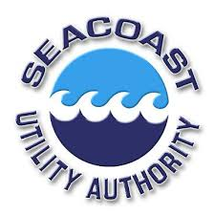
Garden Isles Water Main Replacement/Improvement Project
Public Involvement Plan

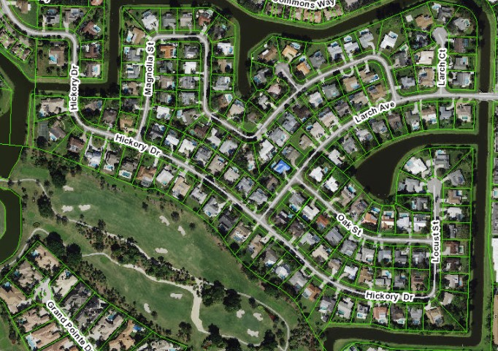

Description
The purpose of this Public Involvement Plan (PIP) is to describe how The Merchant Strategy (TMS) will proactively identify and inform stakeholders of the Garden Isles Water Main Replacement Project. It will be updated periodically throughout the life of the project.
Seacoast Utility Authority (SUA) has identified the need to replace aging water mains in the Garden Isles community in Palm Beach Gardens, Florida, as the existing pipe has reached the end of its useful life. Most of the work will be done “open cut” excavation within the swales located in the right-of-way (ROW) of the public streets. There will be two horizontal directional drills adjacent to the bridges at the east entrance, one on Larch Avenue and the other at the west entrance on Hickory Drive. Once completed any roadways, driveways, landscaping disturbed by construction will be returned to pre-construction condition. As part of infrastructure improvements SUA will locate and install sanitary sewer point of service cleanouts at the property line for future access on all properties that do not currently have such facilities. Potential benefits of replacing the water mains are fewer service interruptions and reduced operation and maintenance costs.
By following the PIP, all interested stakeholders including elected officials, property owners and residents, business owners, schools, places of worship, and the public, will be informed and kept up to date on the proposed improvements. Any issues that arise will be addressed and resolved as the project progresses through the many developmental and construction phases. The objective of this plan is to outline a process for effectively involving the public and ensuring that all interested parties are kept well informed. There will be two neighborhood meetings.

Proposed Scope of the Public Involvement
For a project to be successful, working with the public involves more than meeting requirements and following guidelines. It requires engaging the public, and entails an uncompromising commitment to sharing timely information, listening to and understanding concerns and issues, and developing responses that effectively address issues. Using the many techniques and approaches described in this Public Involvement Plan (PIP) we will work with all stakeholders, providing the means to reach consensus on important issues affecting the community.

Public participation in every phase of a project plays a crucial role in successful implementation. For this project, public interests include residential property owners, tenants, businesses, and institutions in the immediate vicinity of the project, along with neighborhoods, and community organizations concerned with impacts to the area. The interests of environmental groups, utilities, local, state, and elected officials also need to be heard, recorded, understood, and addressed.

Public Involvement includes communicating to all interested persons, groups, and government organizations information regarding the development of the project. The Project Manager will
receive drafts of all public involvement documents (newsletters, property owner letters, and advertisement) associated with the following tasks for review and approval at least ten (10) business days prior to printing and/or distribution. The key objectives of our public involvement effort encompass:

- Proactive outreach to all the above interests
- Early and continuous community participation throughout the process
- Reasonable access to information
- Opportunities for comment prior to key decisions
- Focused community participation on decisions
- Activities to help build positive consensus amongst residents and businesses
- Coordinate neighborhood meeting locations
  - Communicate with public safety departments regarding construction schedules and Maintenance of Traffic (MOT) changes during the project.

The methods and approaches described in the following pages show how these objectives will be met in fostering public participation.

The following are the tasks that will be covered by the public involvement team:
  - Develop a Public Involvement Plan (PIP)
  - Build a database of homeowners and residents, places of worship, schools, and community and government organizations
  - Set up, attend, and report on neighborhood meetings, providing information and talking points for public officials as needed
  - TMS will print and mail a notification flyer providing information on proposed project scope, limits, schedule, anticipated impacts and contact information for the Public Involvement Manager
  - Create public meeting invitations and/or door hangers to be distribute to residents, tenants, and all other stakeholders
  - Locate venue, create materials, attend and provide follow up notes for two neighborhood meetings
  - Develop and maintain a project webpage to be hyperlinked to the SUA’s website with meeting information, MOT updates, maps, documents and photos
  - Set up and staff a project hotline and promptly respond to all hotline inquiries

The Merchant Strategy Public Involvement Team

Sharon J. Merchant
Public Involvement Project Manager
1804 North Dixie Highway, Suite B
West Palm Beach, FL 33407
Tel: (561) 315-9110
E-mail:Sharon@themerchantstrategy.com

Cheryl Scott
Public Involvement Specialist
Tel: (561) 315-9110
E-mail: Cheryl@themerchantstrategy.com

Caylin Ficarra
Public Involvement Specialist
Tel: (561) 315-9110
E-Mail: Caylin@themerchantstrategy.com

PROJECT HOTLINE
(561) 215-9322

Potential Stakeholder Concerns
Current areas of concern include:
- Maintenance of Traffic (MOT)
- Coordinating with stakeholders on street lane closures, detour routes to maintain safety and maximize access for motorists, pedestrians, and bicyclists, and neighborhood meetings
- TMS will notify local emergency services agencies (police, fire, ambulance) and city employees during the development of the temporary traffic control plans to ensure that emergency services are not impacted

Other Temporary Impacts of Construction
Construction by its very nature is disruptive to the surrounding communities and other stakeholders. The following represent concerns that may arise during construction and will be addressed as part of the community outreach:
- Construction traffic including large trucks and excavation equipment
- Dewatering equipment, which may periodically operate overnight
- Dust and dust control activity
- Vibration from construction activities
- Visual/aesthetic/environmental concerns
- Noise/dust from construction activities
- Individual driveways will be closed for short periods of time as pipe installation progresses and restoration work is completed
- Temporary and brief disruption of water service during final connection.
- Restoration of public and private property in the ROW.

Communicating and Responding to the Public
A successful project requires more than just meeting requirements and working with the public. It requires engaging the public, an uncompromising commitment to sharing timely information, listening, and understanding potential concerns and issues, and developing solutions and responses that effectively address these issues. Using the many techniques and approaches described in this PIP, TMS will work with all stakeholders to provide information and to assimilate stakeholder information to the necessary organizations.
Public participation plays a crucial role in every phase of a project. The affected public includes residential property owners and tenants, businesses, and institutions in the immediate vicinity of the project, along with neighborhood, community, and local organizations. The interests of environmental, utility, local, state, and federal agencies and elected/appointed officials also need to be heard, recorded, understood, and addressed.
Public Involvement includes communicating information to all stakeholders during the development of the project. Property owner letters, doorhangers, etc. will be sent to stakeholders as needed. The key objectives of the public involvement efforts are:

• Proactive outreach to all stakeholders
• Early and continuous community participation
• Reasonable access to information
• Opportunities for comment prior to key decisions
• Focused community participation
• Building consensus

Meetings and Events
Neighborhood meetings will serve to inform key stakeholders about project activities and provide a convenient means to disseminate information and obtain feedback. TMS will make arrangements for the meetings, attend meetings, provide materials, take notes, provide edited meeting notes and attendee lists. If Covid-19 social distancing requirements are still in place, meetings can be held virtually via an approved platform such as Zoom or GoToMeetings or via a hybrid meeting where it would be both in person and virtual for those who prefer not to attend in person. The following meetings are anticipated:
- Two Neighborhood Meetings

Printed Materials
TMS will identify meeting locations, prepare notices, and printed meeting materials. All materials will have a professional appearance. Information will be conveyed using text and graphics that can be easily understood by a non-technical audience.
TMS will develop the following materials to facilitate neighborhood meetings:
Sign in Sheets – Attendees will be asked to provide their name, mailing address, email address and telephone number
Comment Cards – Attendees can note any questions, comments or concerns and submit to Public Involvement Team
Presentation/Displays – At a minimum, the following will be developed for neighborhood meetings and displayed or presented:
- Project Location Map
- Project Contact Information
- Aerials of Proposed Improvements (provided by CES)
- Anticipated Project Schedule (provided by CES)
Stakeholders

Utility Agencies/Owners
UAO | Type
A T & T Distribution | Telephone/TV/Internet
Comcast | Telephone
DirecTV | Television/Internet
Florida Power & Light (FP&L) | Electric
Seacoast Utility Authority | Water/Sewer
TECO Peoples Gas | Gas
United States Postal Service | Mail
Waste Management | Solid Waste

Elected/Appointed Officials
Palm Beach County
Public Schools Transportation Division Director, Shane Searchwell
Palm Beach County Fire Chief, Reginald Duren
City of Palm Beach Gardens
Mayor, Rachelle A. Litt
Vice Mayor, Chelsea Reed
Councilmember, Carl W. Woods
Councilmember, Mark T. Marciano
Councilmember, Marcie Tinsley
City Manager, Ron M. Ferris
Public Media Relations Manager, Candice Temple
City Engineer, Todd Engle
Police Chief, Clinton Shannon
Fire Chief, Keith Bryer
Property Owners and Stakeholders
The Property Owner and Stakeholder Database will be updated throughout the duration of the project. The stakeholder database includes persons and organizations that have expressed interest in the project. Prior to the public workshop and other notification mailings, the property owner list will be updated based on the most current SUA Customer Database Records and Palm Beach County Property Appraiser records.

